A Word template for Geodynamica

First Author*,1, Second Author1,2, and Third Author2

1 First affiliation

2 Second affiliation

* [email@address.io](mailto:email@address.io) [corresponding author]

ORCiD (FA): 0000.0000.0000.0000

ORCiD (SA): 0000.0000.0000.0000

ORCiD (TA): 0000.0000.0000.0000

**Short title: 60 characters max for the running head**

Keywords: Please; Provide; Up; To; Five; Keywords

# Abstract

**250 words max.**

# Introduction

## Subsection (as Heading 2)

## Subsection (as Heading 2)

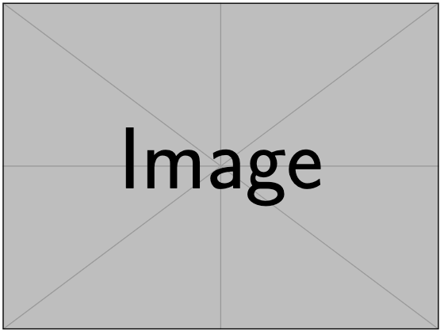

Figure 1: Figures can be inserted in-line or at the end of the manuscript, along with their captions. This is a single-column figure (85 mm).

# Background

# Methods

**Define any equations in the Equation environment:**

$f\left(x\right)=a_{0}+\sum_{n=1}^{∞}{\left(a_{n}\cos{\frac{nπx}{L}}+b_{n}\sin{\frac{nπx}{L}}\right)}$ (1)

where $a_{0}$ corresponds to … Suspendisse a elit ut leo pharetra cursus sed quis diam. Nullam dapibus, ante vitae congue egestas, sem ex semper orci, vel sodales sapien nibh sed lectus. Etiam vehicula lectus quis orci ultricies dapibus. In sit amet lorem egestas, pretium sem sed, tempus lorem.

# Results

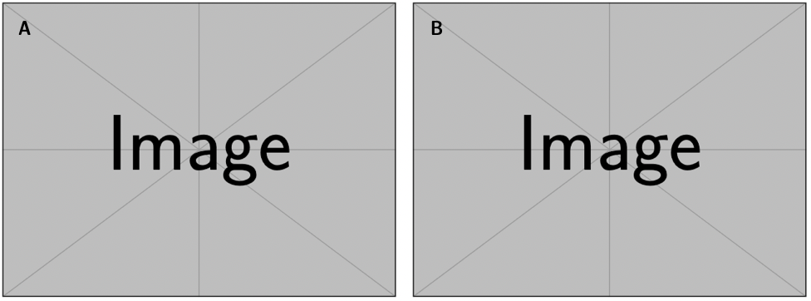

Figure 2: This is a two-column figure (175 mm). Note that separate panels are labelled with an upper-case letter, in a size 12 sans-serif font. [A] Something about the first panel. [B] Something about the second panel.

# Discussion

Table 1: Tables can be inserted directly in the word document. For complex tables and once the manuscript is accepted, the production team might ask for a tabular format (e.g., Excel).

|  |  |  |
| --- | --- | --- |
| Column 1 | Column 2 | Column 3 |
|  |  |  |
|  |  |  |
|  |  |  |
|  |  |  |

# Conclusions

# Acknowledgements

Thank all relevant parties and acknowledge funding sources, if any.

# Author contributions

List the contribution of each author following Contributor Role Taxonomy (CRediT): <https://credit.niso.org/>

# Data availability

Authors should direct readers to an open access repository where the relevant data can be accessed, and provide a statement regarding data availability. Authors are *strongly* encouraged to make data freely available wherever possible: we recommend free repositories such as Zenodo and FigShare in order to facilitate transparent open access. We recommend versioning, archiving, and sharing code via GitHub/Zenodo; see: <https://docs.github.com/en/repositories/archiving-a-github-repository/referencing-and-citing-content>.

# References

References should be included at the end of the manuscript. The style is not important at this stage but **where possible, DOI numbers should be provided.**

**Once the manuscript is accepted, authors will be asked to provide a BibTEX file (.bib; see** [**https://www.bibtex.org/**](https://www.bibtex.org/)**) with all the cited references.** We encourage authors to use a reference manager (e.g., [Zotero](https://www.zotero.org/), [Mendeley](https://www.mendeley.com/reference-management/reference-manager), [Paperpile](https://www.mendeley.com/reference-management/reference-manager), [EndNote](https://endnote.com/?srsltid=AfmBOorHU-SNOTWTNC_Jk5nu8E2DyrFjSanAqZmfGLckQ6lGXUWwQo-a)), which enables generating a BibTEX file easily and quickly.